
Form 1
Capstone Design Proposal
Title : Integrated Operational Management System for C3MR: Web Admin Portal & Telegram Mini App Ecosystem

GROUP MEMBER:
No. | Student Name | Student ID | Study Program
1. | Auza Syamil Nabawi | 001202300150 | Informatics
2. | Rashad Abdul Faqih | 001202300149 | Informatics
3. | Atthariqul Hazam Albanna | 012202300122 | Information System

Advisor : Dr. Adhi Setyo Santoso, ST.MBA.

Submitted for
Capstone Design Project
Faculty of Computer Science
President University
2026

TABLE OF CONTENT

STATEMENT OF ORIGINALITY 3
TITLE 4
CODE GENERATED IMAGE 5
I. PROPOSAL 6
A. PROBLEM FORMULATION 6
1. Background of the Problem 6
2. Problem from a Customer Perspective 6
3. Problem Statement 6
B. PROBLEM ANALYSIS 7
1. Aspect 1: Operational Efficiency (Latency) 7
2. Aspect 2: Data Integrity, Safety, and Privacy 7
3. Aspect 3: Accessibility (User Experience) 7
C. SOLUTION SELECTION & SCENARIOS 7
1. Alternative Solution 1: Mobile Application (Native Android/iOS) 7
2. Alternative Solution 2: Web-Based Dashboard Only 7
3. Alternative Solution 3: Secure Hybrid System (Web Dashboard + Telegram Bot) 7
4. Solution Selection 8
D. DEVELOPMENT EFFORT 8
1. Man power Details 8
2. Development tools 8
3. Test Equipment 8
4. Expert needs 9
5. Cost estimation 9
6. Timelines 9

STATEMENT OF ORIGINALITY
In my capacity as an active student at President University and as the author of the Capstone Design Project stated below:
Name : 1. Auza Syamil Nabawi – 001202300150
2. Rashad Abdul Faqih – 001202300149
3. Atthariqul Hazam Albanna – 012202300122
Faculty : Computer Science
I hereby declare that my Capstone Design Project entitled “Integrated Operational Monitoring System for Telkomsel C3MR Data: A Secure Hybrid Approach Using Web Dashboard and Telegram Bot” is to the best of my knowledge and belief, an original piece of work based on sound academic principles. If there is any plagiarism detected in this final project, I am willing to be personally responsible for the consequences of these acts of plagiarism and will accept the sanctions against these acts in accordance with the rules and policies of President University.
I also declare that this work, either in whole or in part, has not been submitted to another university to obtain a degree.

Cikarang, 2026
Signer 1 | Signer 2 | Signer 3
 | 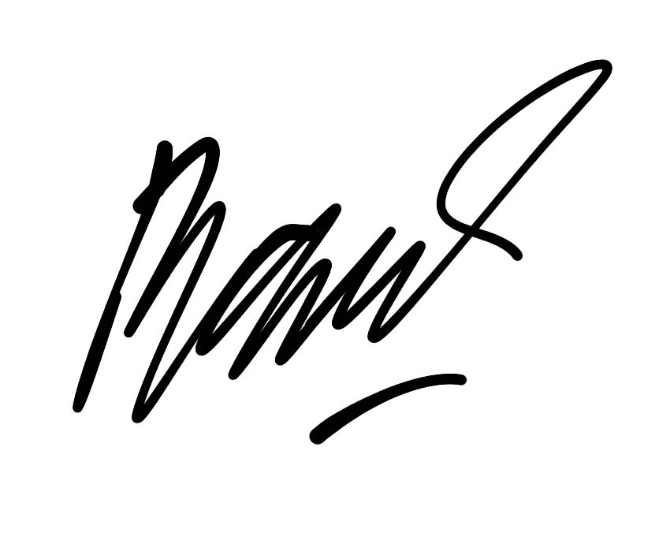 | 
Auza Syamil Nabawi  001202300150 | Rashad Abdul Faqih  001202300149 | Atthariqul Hazam Albanna  012202300122

TITLE

Approved:

Dr.Adhi Setyo Santoso, ST.MBA.  Capstone Advisor | Rosalina, M.Kom.  Program Head of Informatics Study Program

Prof. Dr. Ir. Wiranto Herry Utomo, M.Kom.
Dean of Faculty of Computer Science

PROPOSAL

PROBLEM FORMULATION

Background of the Problem
The operational efficiency of Telkomsel's Collection Team (C3MR) is currently hampered by its reliance on manual workflows, which cause bottlenecks in the data processing cycle. This problem stems from the administrative side, which still implements manual target extraction and distribution processes using spreadsheets via instant messaging applications. This is further exacerbated by limitations in the field, where Caring Territory Base (CTB) officers are not supported by adequate digital reporting devices, forcing them to report manually via text or access heavy documents via mobile devices. This system mismatch between the office and the field ultimately resulted in double handling for administrative staff, who had to manually and repeatedly input target distribution and recapitulate daily reports, creating redundant work that significantly slowed the team's productivity.

Problem from a Customer Perspective
From the perspective of Field Officers (Collection Team) and Regional Managers:
- Admin Staff: Overwhelmed by the manual process of splitting Excel data and re-typing field reports.
- ⁠Field Officers: Frustrated by the lack of a proper reporting tool. Using standard chat is unstructured, while installing a heavy native Android app is problematic for officers with low-spec devices.
- Management: Cannot view real-time progress because data is only updated after the manual recap is finished.

Problem Statement
⁠Problem Statement How can we build an integrated system that provides a Web Portal for Admins to input/assign tasks and a Lightweight Tool for Officers to report results, without requiring the installation of heavy mobile applications?.

Objective
- ⁠Develop a Web Admin Portal specifically for Office Staff to input targets, manage customer data, and assign tasks to field officers digitally (replacing manual Excel Work).
- ⁠Develop a Telegram Mini App (an integrated web interface within Telegram) for Field Officers to input visit results and upload evidence directly inside Telegram.
- ⁠Develop a Summary Bot that provides simple, read-only performance recaps for management.

PROBLEM ANALYSIS

Aspect 1: Operational Efficiency (Latency)
⁠Aspect 1: Workflow Efficiency (Digitizing Input) The core issue is the manual entry on both ends (Admin & Field). The current process involves: Excel -> Manual Chat -> Manual Report -> Manual Recap. Analysis: The new system must digitize the source. Admin inputs targets directly into the Web Portal, and Officers input results directly into the Mini App. This eliminates the need for manual recaps.

Aspect 2: Data Integrity, Safety, and Privacy
Aspect 2: Accessibility (Zero-Install Experience) Field officers use various types of smartphones. Requiring them to download, install, and update a native Android file (.apk) creates friction and compatibility issues. Analysis: A Telegram Mini App is the optimal solution. It runs on the cloud within the existing Telegram app, requiring zero installation while offering the functionality of a native app (forms, buttons, uploads).

Aspect 3: Accessibility (User Experience)
Aspect 3: Data Integrity Manual text reporting in chat groups leads to unstructured data (typos, wrong formats). Analysis: The system requires structured input forms (Dropdowns for Status, Date Pickers, Photo Uploads) to ensure data is clean and valid before it reaches the server.

SOLUTION SELECTION & SCENARIOS

Alternative Solution 1: Native Mobile App (Android)
Building a dedicated .apk file for field officers.
- ⁠Pros: High performance and full hardware access.
- Cons: High development cost, difficult distribution (manual APK sharing), and high resistance from users with full storage.

Alternative Solution 2: Web-Based Only System
A responsive website for both Admins and Officers.
- ⁠Pros: Single codebase.
- ⁠Cons: Officers in the field find it inconvenient to constantly login/logout of a browser. It lacks the immediate "Push Notification" capability of a chat app.

Alternative Solution 3: Integrated Ecosystem (Web Portal + Mini App)
- Deskription :
- Web Admin Portal: For "Heavy Input" (Admin inputting targets & assigning tasks).
- Telegram Mini App: For "Field Input" (Officers reporting results).
- Pros: Provides the best UX for both roles. Admins get a full screen for data entry; Officers get a fast, familiar interface in Telegram without installing anything new.

DEVELOPMENT EFFORT

Man power Details
- Auza Syamil Nabawi (Informatics): Frontend & UI. Responsible for building the Web Admin Portal (React.js) for data input and the Telegram Mini App UI for field reporting.
- Rashad Abdul Faqih (Informatics): Backend & Database. Responsible for the Database Schema (PostgreSQL) that connects the Web and Telegram, and developing the API using Python FastAPI.
- Atthariqul Hazam Albanna (Information System): Analyst & QA. Responsible for mapping the "Input Flow" (UX), defining the requirements for the Web Portal, and conducting User Acceptance Testing (UAT).

Development tools
- Languages: Python 3.10 (Backend), JavaScript/TypeScript (Frontend).
- Frameworks: FastAPI, React.js, Telegram Web Apps SDK
- Database: Supabase (PostgreSQL).
- Tools : Visual Studio Code, Postman, Git.

Cost estimation
Item | Description | Estimated Cost (IDR)
VPS Server | Cloud Server (2 vCPU, 4GB RAM) for 6 months | Rp 1.200.000
Domain Name | .com / .id domain for Dashboard | Rp 150.000
Supabase | Database Hosting (Free Tier / Pro) | Rp 0 (Free Tier)
Connection | Internet Data for Development | Rp 600.000
Total |  | Rp 1.950.000

Timelines
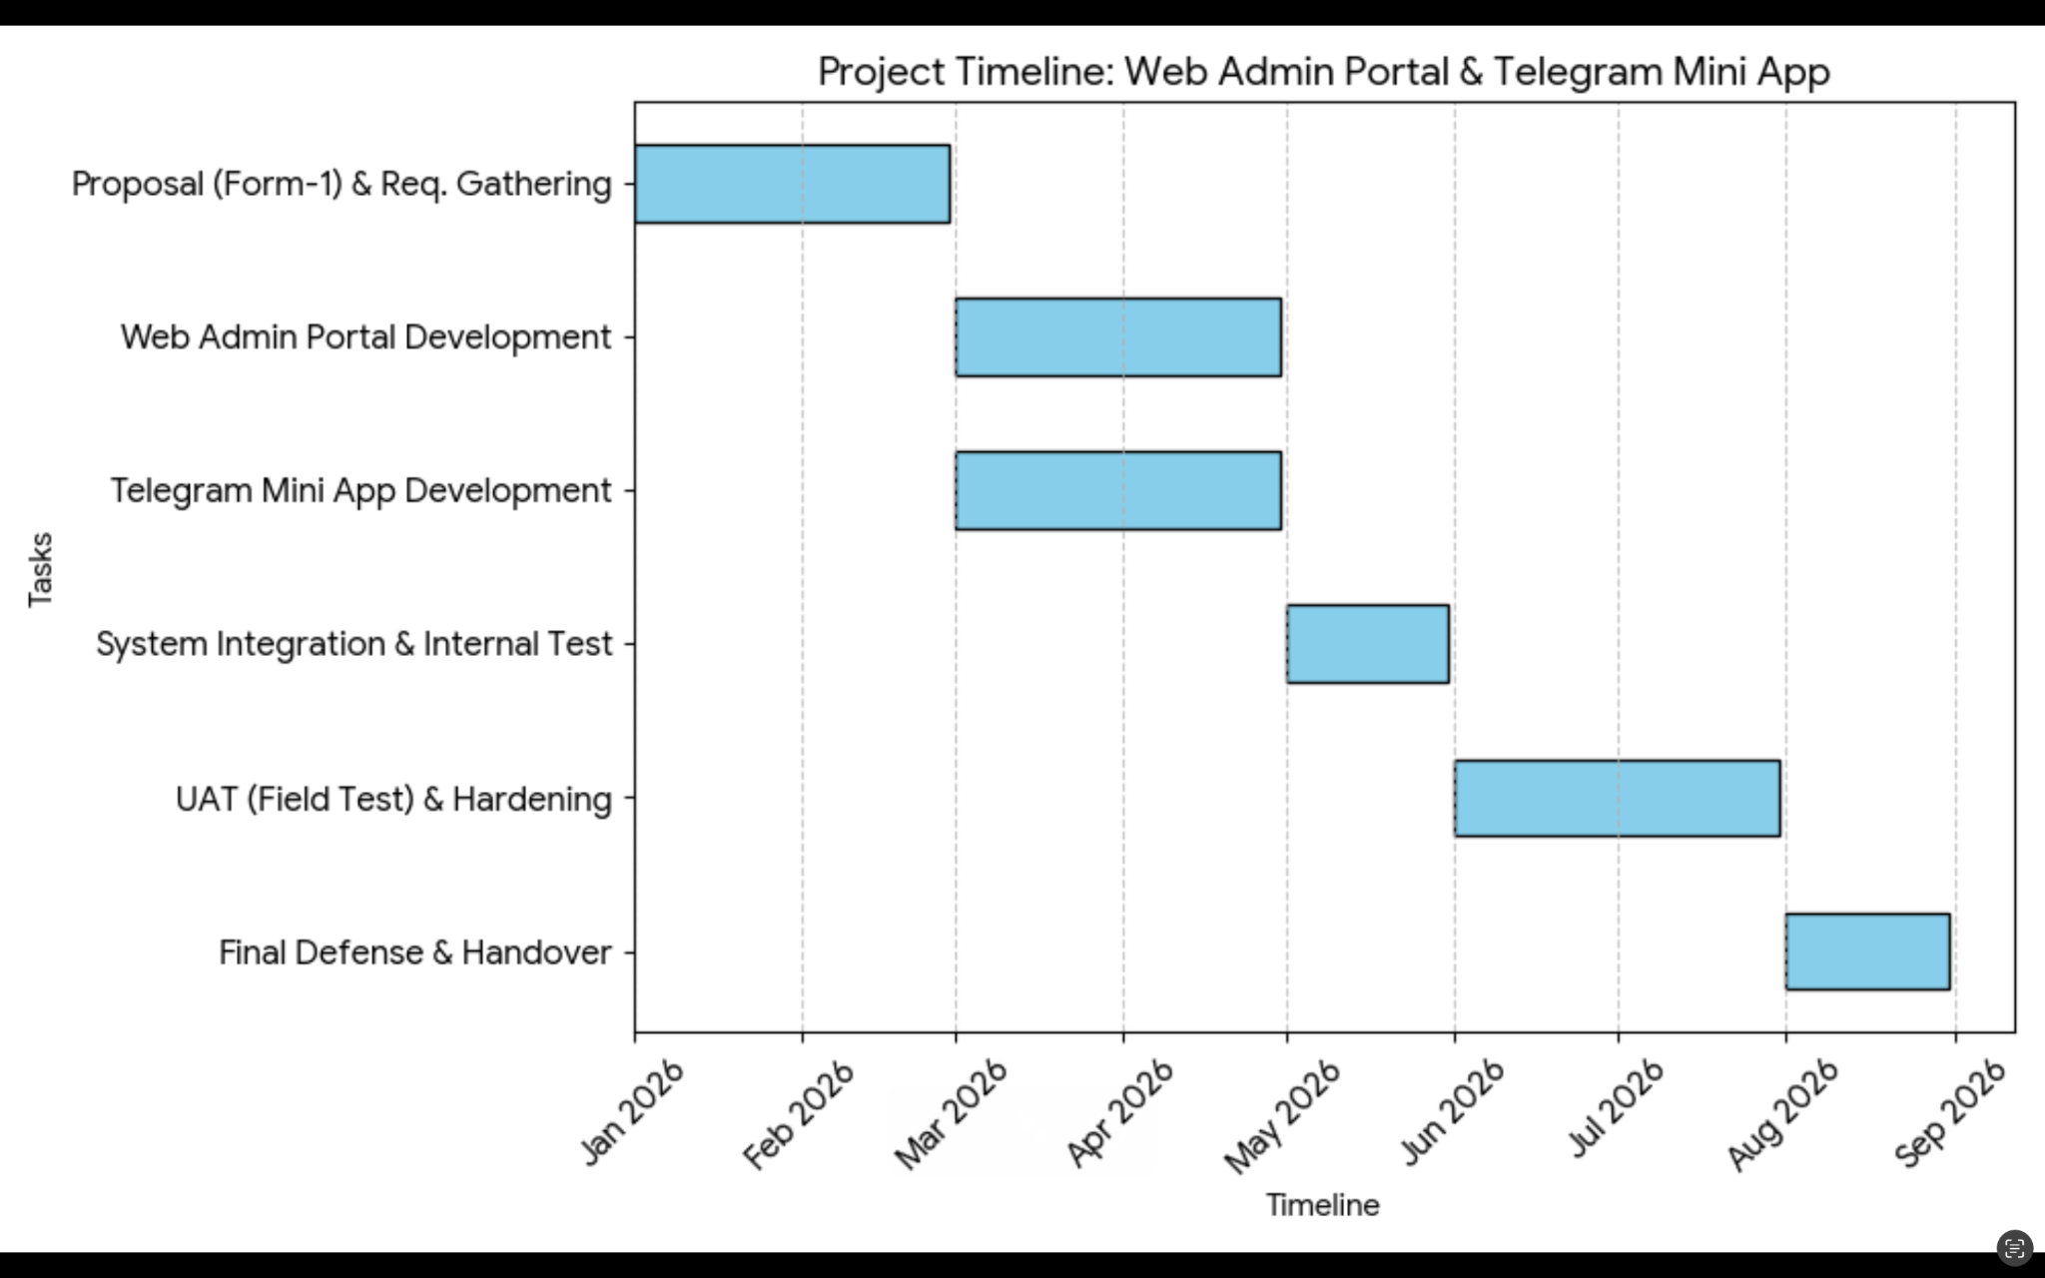
( C3MR Project Timeline (January - September 2026) )

Information regarding the timeline for the
Integrated Operational Monitoring System (C3MR) Project
- Proposal (Form-1) & Requirements Gathering
Period: January 2026 - early February 2026
- Initial phase of the project for proposal preparation and system requirements gathering.
- Duration: approximately 1 month
- System Analysis (Form-2) & DB Design
Period: Mid-February - early March 2026
- System analysis and database design
- Duration: approximately 2-3 weeks
- Marked in red to indicate critical phases
- Backend API & Bot Dev (Form-3)
Period: Early March - late April 2026
- Backend API and bot development
- The longest phase in development, duration approximately 2 months
- This is the core phase of system development
- Web Dashboard Dev (Form-4)
Period: Late April - early June 2026
- Web-based dashboard development
- Duration approximately 1.5 months
- Marked in red indicates an important deliverable phase
- Security Hardening & UAT (Form-5)
Period: Early June - early July 2026
- System security reinforcement and User Acceptance Testing
- Duration of approximately 1 month
- Final Report & Early Defense
Period: Early July - early August 2026
- Final report preparation and preliminary defense
- Duration of approximately 1 month
- Marked in red as an important milestone
- Capstone Final Defense
Period: Mid-August - end of September 2026
- Final capstone project defense
- Project closing phase
Notes : Red color on the timeline indicates critical phases or important milestones that require special attention in project completion.

REFERENCES
- President University Capstone Design Project Guidelines.
- Telegram Bot API Documentation.
- Supabase Documentation.
- OWASP Top 10 Security Guidelines.

